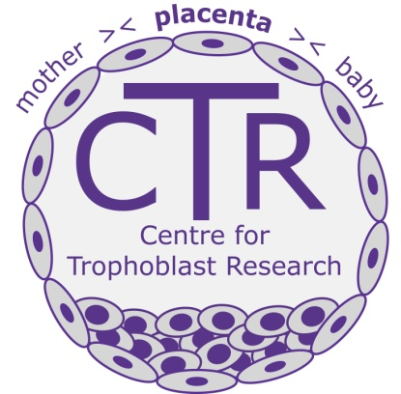
CTR Practical Courses 2017

Placental Biology Course
2nd – 7th July, 2017

The Centre for Trophoblast Research, University of Cambridge
will again run its acclaimed course in contemporary placental research
2nd – 7th July 2017

Introduced in 2012, the course is aimed primarily at graduate students and
post-doctoral research associates.
Topics include:

- Human and mouse placental development | - Epigenetics
- Comparative placentation | - Trophoblast stem cells
- Immune cells and placentation | - Placental transport
- Microarray and sequencing techniques | - Oxygen metabolism
- Cell isolation and culture  - Explants | - Plus, clinical study design, journal club, fellowship/grant writing workshop
Course fee of £1500 will cover tuition, consumables, College accommodation, meals and optional free attendance at the CTR Annual Trophoblast Meeting (10th-11th July 2017.) The number of participants will be restricted to ensure personal tuition.

Course instructors:

* Graham Burton * Erica Watson * Amanda Sferruzzi-Perri
* Wolf Reik * Myriam Hemberger * Anne Ferguson-Smith
* Ashley Moffett * Francesco Colucci * Andrew Sharkey
* Abby Fowden * Andrew Murray * Miguel Constância
* Gordon Smith * Russell Hamilton * Tereza Cindrova-Davies
* Steve Charnock Jones * Dino Giussani
* Johnnie Bremholm Andersen *Mick Elliot

Further information is available at www.trophoblast.ac.uk. Applications open in January 2017

"By far the best biology course I have been on...so helpful and relevant"

"This course has huge potential for directing and shaping the future of research in the field"

Feedback from 2016 delegates
