 | 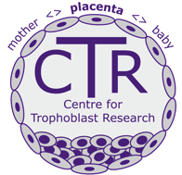

Next Generation Fellowship Application
- CV

Degree details (please list most recent degree first):
Dates: | Degree: | Level: | University:

Present and past jobs/positions (most recent first):
Dates: | Company, address & website: | Job title: | Duties:

Publications (most recent first):
Awards/prizes/honours (most recent first):
- Summary of research project (3,000 words maximum, excluding references) including brief details of how you see your research developing in the longer term

- Estimated financial breakdown of the costs for each year
 | Salary | Consumables | Equipment | Animals | Facilities charges | Totals:
Year 1:
Year 2:
Year 3:
 |  |  |  |  | Grand total:

- Please enclose three confidential academic references in sealed envelopes.
- Please enclose a letter of support from your proposed Sponsor.
Please forward all this information to the CTR administrator at the address below:

CTR Administrator
Centre for Trophoblast Research
Dept. of Physiology, Development & Neuroscience
Physiological Laboratory
Downing Street
Cambridge, CB2 3EG

