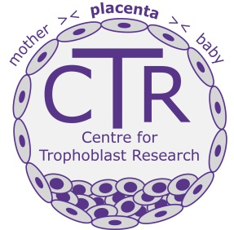CTR 10th Anniversary Trophoblast Meeting 2017
Venue: Palmerston Room, St. Johns College, Cambridge

Monday 10th July

2.00 pm to 5pm
Open presentations from delegate submissions

Tuesday 11 July
8.30-9.10 Registration and coffee
Welcome
9.10-9.30 Graham Burton Introduction to the CTR
Trophoblast biology
9.30- 9.50 Myriam Hemberger
Transcriptional and epigenetic regulation of the trophoblast lineage

9.50-10.10 Margherita Turco
Trophoblast and endometrial organoids

10.10-10.30 Sarah Teichmann
Understanding Cellular Heterogeneity

10.30-10.50 Kathy Niakin
Mechanisms of lineage specification in human embryos

11.00-11.30 Coffee
Placentation
11.30-11.50 Magda Zernicka-Goetz
Building the mammalian embryo … one step closer
11.50-12-10 Anne Ferguson-Smith
Genomic imprinting and the development, function and epigenetics of the placenta
12.10-12.30 Francesco Colucci
Maternal innate lymphocytes and reproduction
12.30-12.50 Ashley Moffett
Border Control by the Immune System at the Placenta/Uterine Boundary

1.00-2.00 Lunch
Placental Physiology
2.00-2.20 Miguel Constancia
Maternal-fetal resource allocation

2.20-2.40 Yoel Sadovsky
Pathways underlying trophoblastic cell defense against viral infection

2.40-3.00 Romina Plitman
Computational modelling of placental function

3.00-3.20 Gordon Smith
Placental biomarkers for human disease
3.30-4.00 Tea
Placenta and health
4.00-4.20 Kent Thornburg
Title to be confirmed
4.20-4.40 Dr David Weinberg
Title to be confirmed

4.40-5.00 Lesley Regan
The RCOG Leading Safe Choices Programme

5.00-5.20 Annettee Nakimuli
The immunogenetics of pre-eclampsia in an indigenous African population

5.20-5.40 Joy Lawn
Reproduction and global women’s health
5.40 Graham Burton Close

7.00 Reception
7.30 Dinner
The Hall St. Johns College, Cambridge
Welcome Address Master of St John’s
Addresses from the Vice-Chancellor
Abby Fowden (SBS)
Patrick Maxwell (Clin School)
Response from Wolf Reik (SAB)

